Technical Report
Embedded System Project: PC FAN speed controller
Author: Martins Osemudiamen Okoh.
TU Dublin ID: A0004717

Aim: Design and implementation of a PC fan speed controller using STM32L432KC microcontroller.

Objective:
- Schematic design of the PC fan speed controller.
- Software implementation.
- Hardware implementation.
- Testing / Debugging.
- Documentation.

Design:
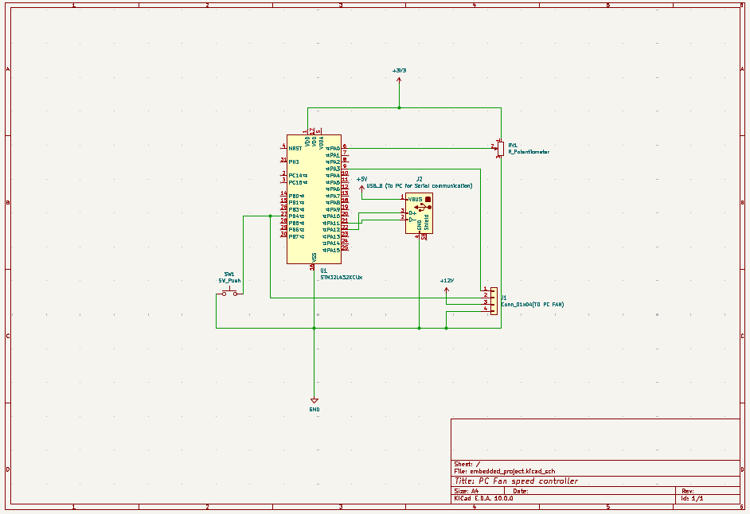
Figure 1: Ciricuit Design of PC fan controller using KICad 10.0.

In the Figure 1 above, the design comprises of a push button, potentiometer, PC fan 4 wire connector, a USB cable component for serial communication, voltage supplies of 3.3 and 12 voltages and a ground.

Source Code:

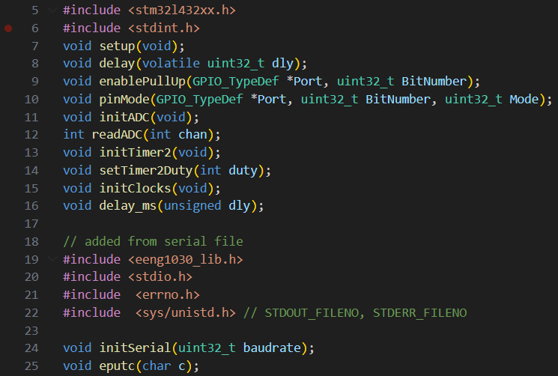
Figure 2: Declaration of functions and addition of necessary files and libraries.

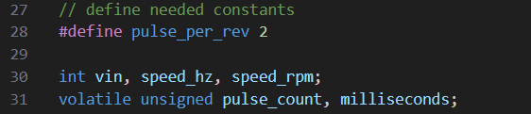
Figure 3: Declaration of global variables.

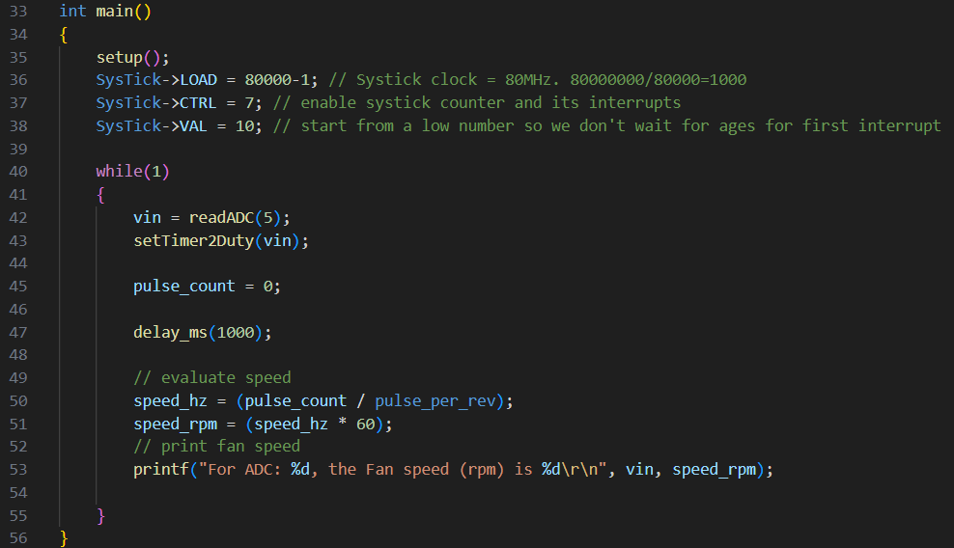
Figure 4: Main function of the software implementation.
As shown in Figure 4 above, the sequence flow of the code starts with the setup function and the clock counter with interrupt. A continuous loop is initiated, which reads the resistor value from the potentiometer that controls the PC speed. A variable, pulse_count, is firstly initialized to 0 and a milliseconds delay of 1000 is then performed. This delay ensures the pulse_count is captured accurately and its value is used to estimate the PC fan speed in revolutions per minute. The speed with the potentiometer level is read via serial communication unto the terminal display using the equation (1) below.

RPM = (pulse_count / pulses_per_rev) * 60 ……………….……………….(1)

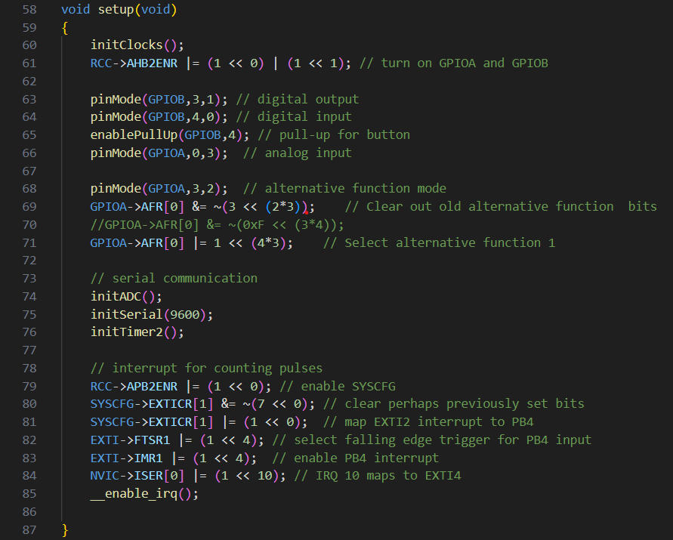
Figure 5: Function setup.

The setup function shown in Figure 5 above includes pin definitions, functions for initialization of clocks, serial communication to display terminals and interrupt for pulse counting. The interrupt is mapped to PB4 pin which is enabled and select the falling edge of the tachometer signal / speed signal from the fan feed to the PB4 pin. GPIO pins are set (PA3 , PA0,PB4 ) as inputs and outputs.
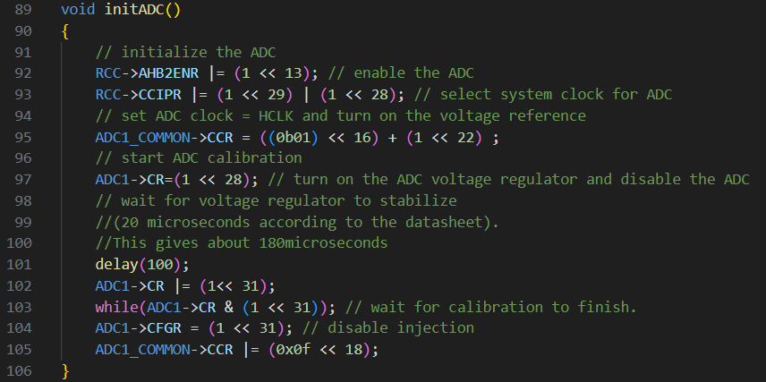
Figure 6: Analogy to digital conversion initialization function.

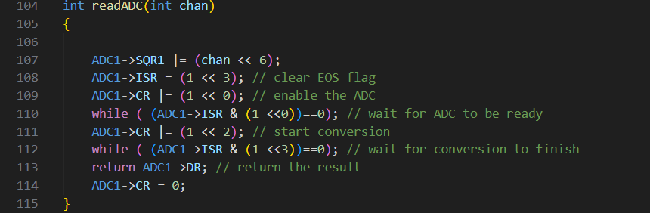
Figure 7: Analogy to digital conversion reading function.


Figure 8: Function of installing delay.

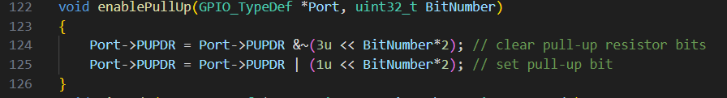
Figure 9: Function to enable pull-up resistor.

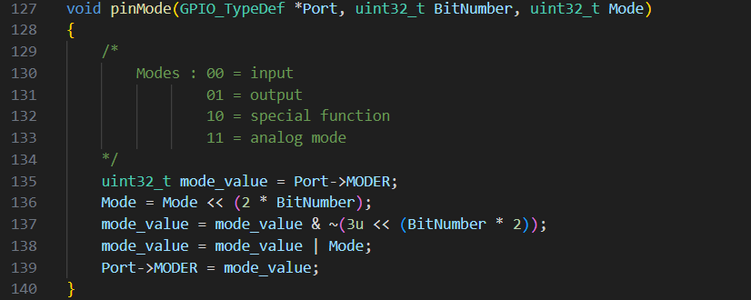
Figure 10: Function for PIN mode selection.

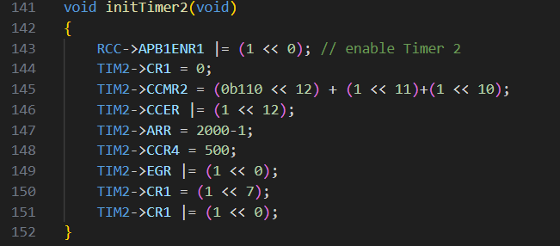
Figure 11: Function for initializing timer.

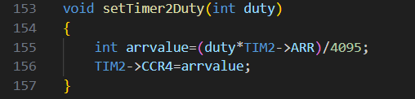
Figure 12: Function for setting timer for pulse width modulation duty cycle.

In Figure 12 above, the duty setting of the potentiometer from 0 to 4095 is done.

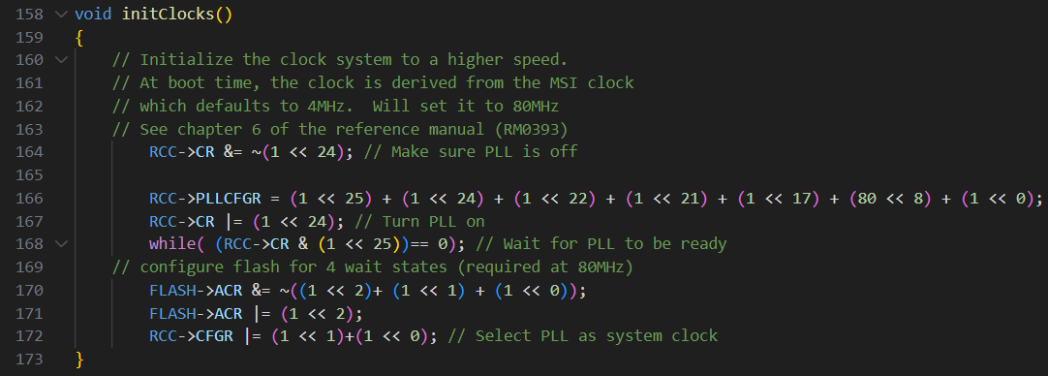
Figure 13: Function for initializing clock

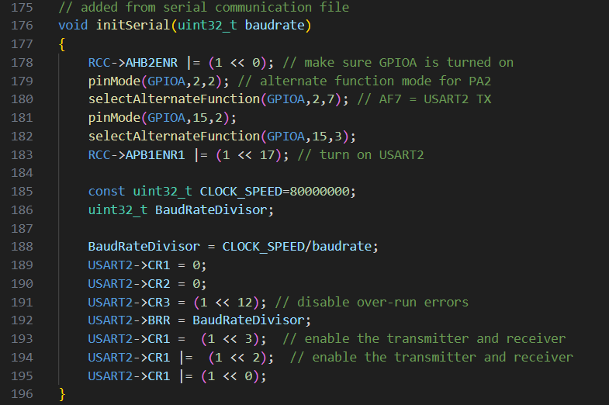
Figure 14: Function of initializing serial communication and pin definition.

Figure 14 above shows how the PA2 and AF7 are set internally for transmitting and receiving of data via the USB serial cable.

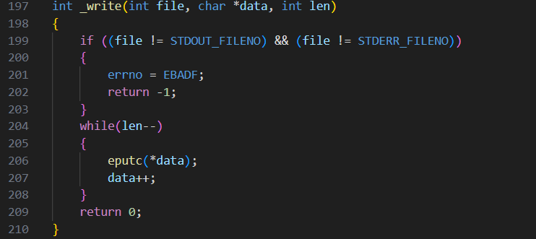
Figure 15: Function for writing via serial communication.

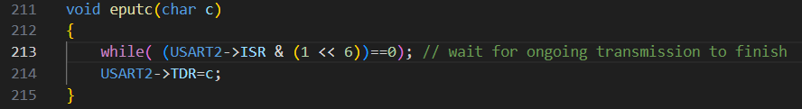
Figure 16: Function for write via serial communication to terminal display.

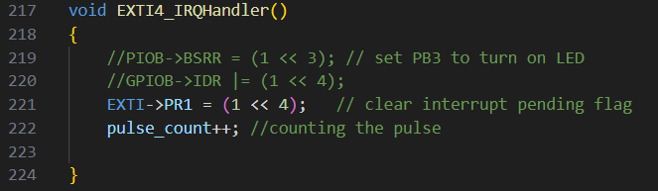
Figure 17: Function to handle interrupt to counting the pulse for the speed estimation of the PC fan.

The Figure 17 above show the using of PB4 for interrupt handling and the pulse_count variable increment performed to track the speed signal.

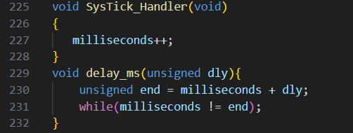
Figure 18: Function for milliseconds counting and delays.

The Figure 18 above show the using creation of a millisecond delay to enable precise tracking of the speed signal which enables the pulse_count increment.

Testing:

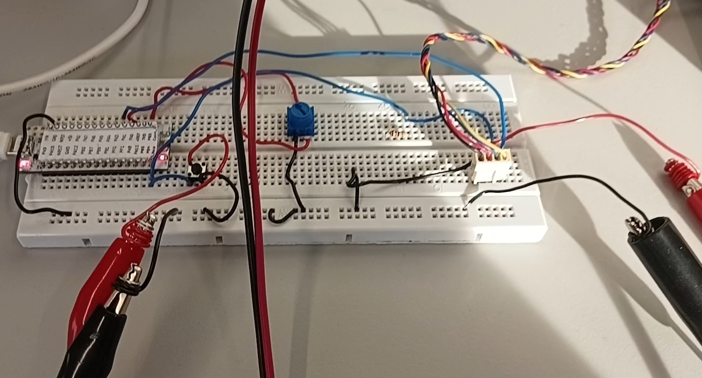
Figure 19: Hardware implementation of bread board.

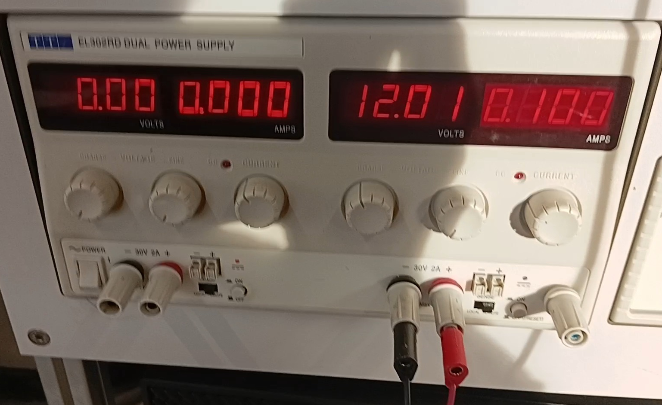
Figure 20: Power supply.

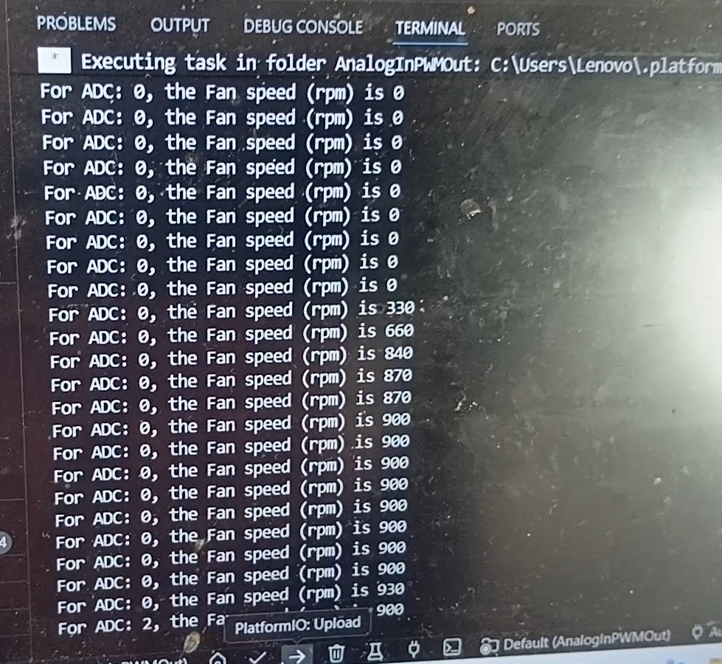
Figure 21: Output result 1 on terminal.

The result in Figure 21 shows the speed of max of 930 revolution per minute when the potentiometer is at minimum level.

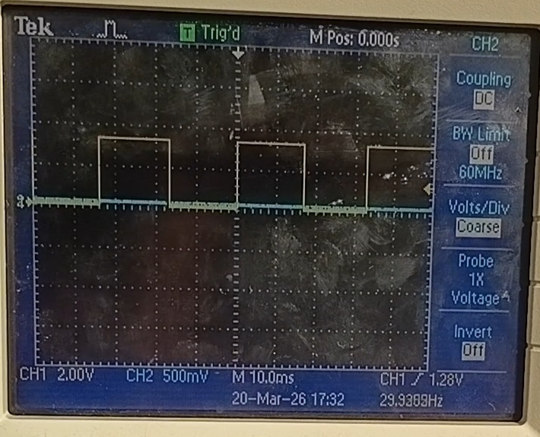
Figure 22: Fan output speed signal 1 viewed on oscilloscope.

The result in Figure 22 shows the output speed signal from the PC fan with a frequency of 29.9Hz.
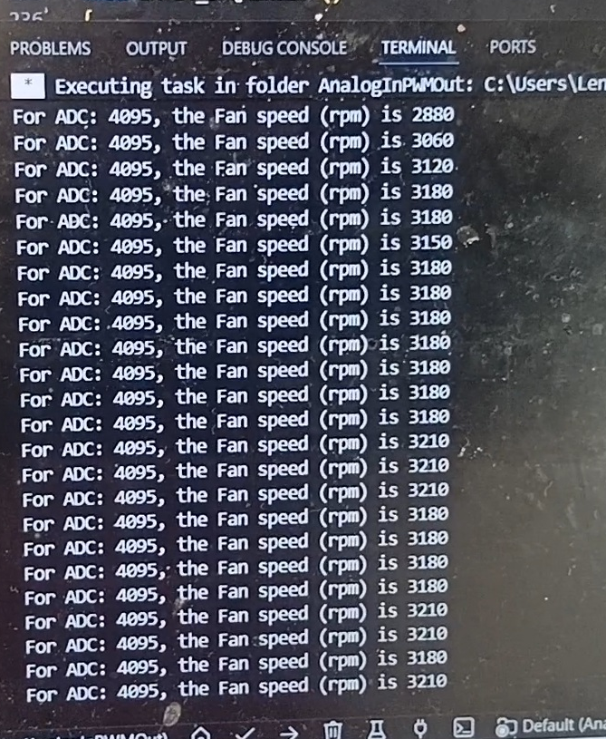
Figure 23: Output result 2 on terminal.

The result in Figure 23 shows the speed of max of 3210 revolution per minute when the potentiometer is at maximum level.

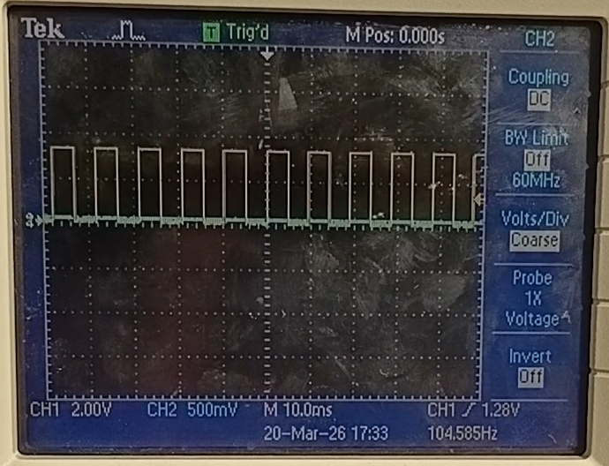
Figure 24: Fan output speed signal 2 viewed on oscilloscope.

The result in Figure 22 shows the output speed signal from the PC fan with a frequency of 104.58Hz.
Conclusion:

The project aim and objective were observed to have been achieved. The circuit design, software and hardware implementation were effective performed. The fan speed is able to be controlled by a potentiometer and the serial communication is able to read the speed value unto the terminal. An oscilloscope was used to perform hardware debugging while break points were used for software code debugging.

References:
- M. S. Waghare, D. R. Tutakne, A. N. Deshmukh, and M. M. Mardikar, “PWM controlled high power factor single phase fan regulator,” in Proc. 3rd Int. Conf. Electronics, Communication and Aerospace Technology (ICECA), 2019, pp. 59–64, doi: 10.1109/ICECA.2019.8822156.

